**Math Reviewer**

**Polygons**

* Comes from the Greek word “polygonon,” meaning **poly = many**, and **gon = angles**.
* Cannot have curves or gaps.
* More than 3 sides.

|  |  |  |
| --- | --- | --- |
| **Name of Polygon** | **Number of Sides** | **Sum of Interior Angles** |
| Triangle | 3 | 180° |
| Quadrilateral | 4 | 360° |
| Pentagon | 5 | 540° |
| Hexagon | 6 | 720° |
| Heptagon | 7 | 900° |
| Octagon | 8 | 1080° |
| Nonagon | 9 | 1260° |
| Decagon | 10 | 1440° |
| Undecagon | 11 | 1620° |
| Dodecagon | 12 | 1800° |

**Polygon**

* Plane figure formed by three or more segments.

**Angles and Sides of Polygon**

|  |  |  |
| --- | --- | --- |
| **Name** | **Description** | **Ex.** |
| **Consecutive Sides** | Two sides of a polygon that share a common endpoint. | and |
| **Consecutive Angles** | Two angles whose vertices are endpoints of the same side. |  |
| **Included Side (of Two Angles)** | The common side of two consecutive angles. | ∠P and ∠A. |
| **Included Angle (of Two Sides)** | The angle containing the common vertex of two consecutive sides. |  |
| **Diagonal (of a Polygon)** | A segment joining any two nonconsecutive vertices. |  |

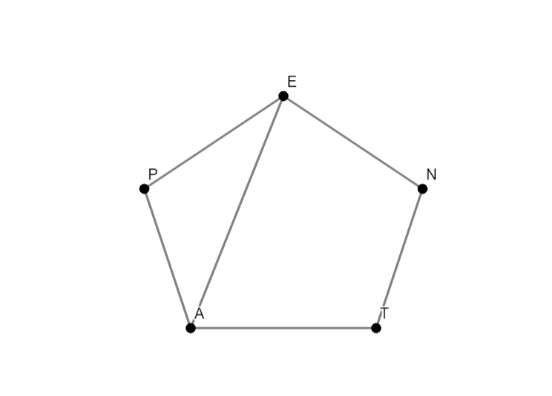

**Polygonal Region**

* **Polygonal Region** – A polygon and its interior.
* **Interior** – A polygon completely enclosed a region of the plane.
* **Concave** – Polygonal regions that bend inward.
* **Concave Polygon** – A polygon that determines a concave region.
* **Convex** – Polygonal region that do not bend inward
* **Convex Polygon** – A polygon that determines a convex region.
* **Regular Polygons** – A polygon with congruent sides and angles.
* Circles are concaves.
* Any curved side are concaves.

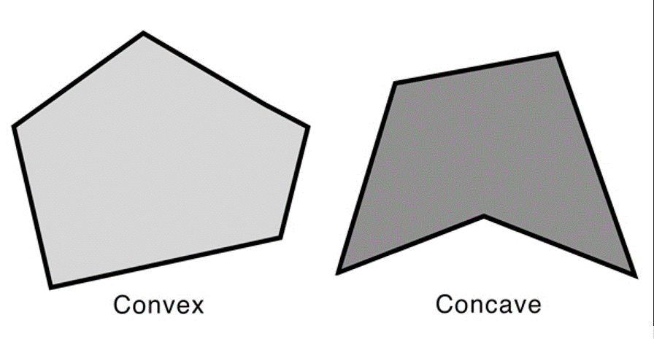

**Special Quadrilaterals:**

|  |  |  |
| --- | --- | --- |
| **Name** | **Description** | **Shape** |
| **Parallelogram** | A quadrilateral with both pairs of opposite sides is parallel. |  |
| **Rhombus** | A parallelogram with four congruent sides. |  |
| **Rectangle** | A parallelogram with four right angles. |  |
| **Square** | A parallelogram with four right (90°) angles. |  |
| **Kite** | A Quadrilateral with two pairs of adjacent congruent and no opposite sides congruent. |  |
| **Trapezoid** | A quadrilateral with exactly one pair of parallel sides. |  |

**Classifications of Triangles**

|  |  |
| --- | --- |
| **Name** | **Shape** |
| **Scalene** |  |
| **Equilateral** |  |
| **Obtuse** |  |
| **Isosceles (Congruent)** |  |
| **Acute** |  |
| **Right** |  |

**Measuring Angles in a Triangle**

* **Property 1** - The sum of the degree measures of the interior angle of a triangle is 180°
* **Property 2**–If two angles of one triangle are congruent to two angles of another.
* **Property 3** – The measure of an exterior angle of a triangle is equal to the sum of the measures of its two remote interior angles.
* **Exterior Pair** – An angle that forms a linear pair with an angle of the triangle.

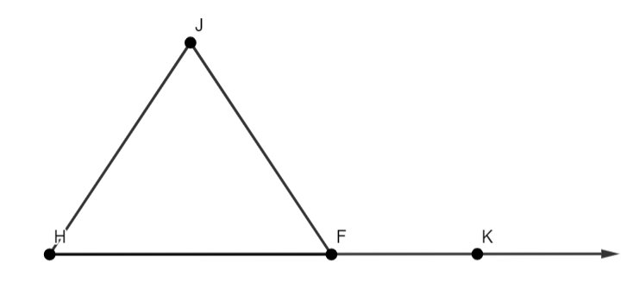

* **Remote Interior Angle** – An angle that forms a linear pair with an angle of the triangle.

∠H and ∠J

* **Adjacent Interior Angle** –
* **Exterior Angle** - ∠K

**Angles in a Polygon**

**Property 1**

* The same of the measures of a convex quadrilateral is 360°.

**Property 2**

* The sum of the measures of the angles of a convex polygon n side.
* n = Number of sides
* **Formula**

**Property 3**

* The sum of the measures of the exterior angles one at each vertex 360°

**Corollary**

* **Formula**

**Circles and Related Terms**

|  |  |  |
| --- | --- | --- |
| **Name** | **Description** | **Shape** |
| **Circle** | The set of all points in a plane from a given point known as the center of the circle. |  |
| **Radius** | A segment whose endpoints are the center a point on the circle. |  |
| **Chord** | A segment whose endpoints lie on a circle |  |
| **Diameter** | Longest chord in a circle and twice the length of a radius. |  |
| **Secant** | A line intersecting the circle at two points. |  |
| **Tangent** | A line intersecting the circle at one point. Point of intersection is called “Point of Tangency.” |  |
| **Sector** | The part of a circle enclosed by two radii of a circle and arc. |  |

|  |  |
| --- | --- |
| **Arc** |  |
| **Semicircle** – Half of a circle. |  |
| **Segment** |  |
| **Inscribed Angle** – Vertex lies on the circle. |  |
| **Central Angle** – Vertex is on the center. |  |